Project Documentation
Product Inventory Management

1. Introduction
- Project Title: Product Inventory Management
- Team ID: SWTID-2026-3386
- Team Leader: R.kavisha devi kavishadevi123@gmail.com
Team Members:
- S.monika mon633977@gmail.com
- S.eswari eswari062006@gmail.com
- K.yasotha yasoyaso2809@gmail.com

2. Project Overview
- Type: Backend REST API Project
- Technologies: Node.js, Express.js, MongoDB, JWT Authentication
- The Product Inventory Management System is a backend web application designed to manage product data through REST APIs.
- The system allows users to register, log in securely, and manage their own product inventory.
- Each user can create, view, update, and delete products.
- Authentication is implemented using JSON Web Tokens (JWT) to ensure that only authorized users can access protected routes.

3. Architecture
- Backend: Node.js with Express.js
- Database: MongoDB using Mongoose ODM
- Authentication: JWT (JSON Web Token)
- Architecture Pattern: MVC (Model – Controller – Route)

- Setup Instructions Prerequisites:
  - Node.js
  - Npm
  - MongoDB
  - VisualStudioCode

- Installation Steps:
  - Open terminal in the project folder
  - Run: npm install
  - Configure environment variables in .env file
  - Start server using: npm start

- Folder Structure:
server/
│
├── node_modules/
├── src/
│ ├── controllers/
│ │ ├── auth.controller.js
│ │ └── product.controller.js
│ ├── db/
│ │ └── db.js
│ ├── middlewares/
│ │ └── auth.middleware.js
│ ├── models/
│ │ ├── User.js
│ │ └── Product.js
│ ├── routes/
│ │ ├── auth.routes.js
│ │ └── product.routes.js
│ └── server.js
│
├── .env
├── package.json └── package-lock.json

6. API Documentation
- Authentication APIs: o POST /api/v1/auth/register – Register a new user o POST /api/v1/auth/login – Login and receive JWT token
- Product APIs: o POST /api/v1/products – Create new product o GET /api/v1/products – Get all products for logged user o PUT /api/v1/products/:id – Update product
o DELETE /api/v1/products/:id – Delete product

7. Authentication
- JWT authentication is used to secure protected routes.
- After a successful login, a token is generated and must be sent in the Authorization header as 'Bearer <token>' to access product APIs.

8. Testing
- APIs were tested using Thunder Client extension in Visual Studio Code.
- Testing included user registration, login authentication, product creation, product retrieval, update, and deletion.

9. Screenshots
- Register API response
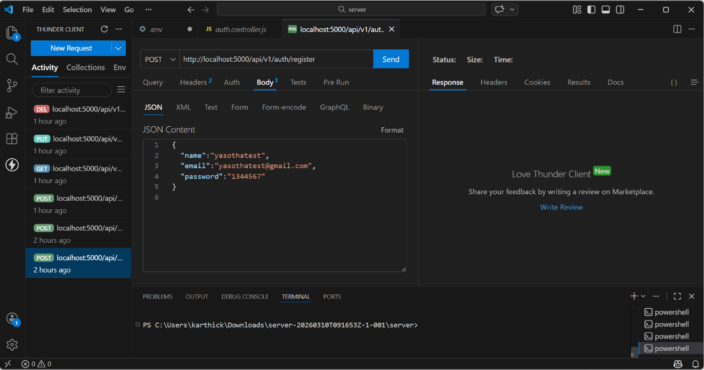

- Login API response
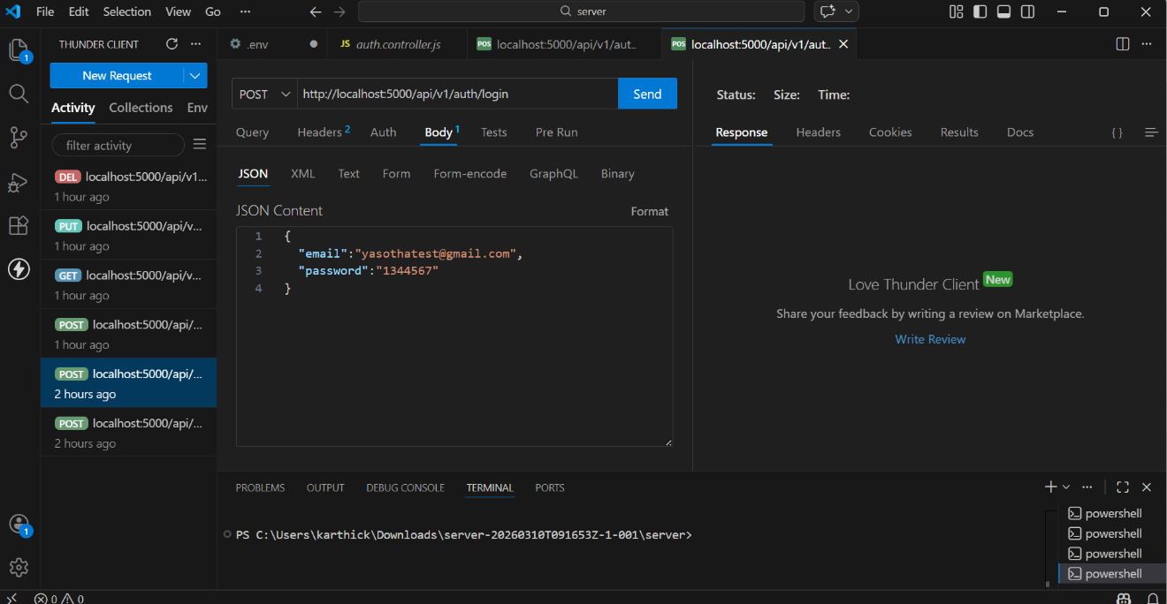

- Create Product API

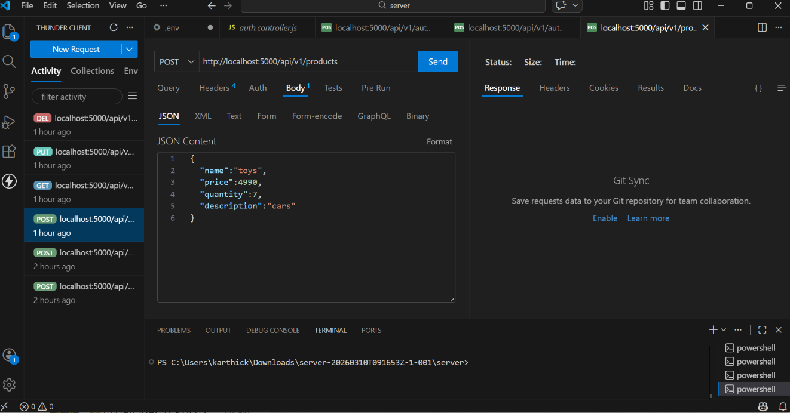

10. Known Issues
No major issues reported during development and testing.

11. Future Enhancements
- Add frontend interface using React
- Implement product image upload
- Add pagination and advanced search
- Add role-based access control

